

*Semester Two, 2019*

Question Booklet

**YEAR 9.01/9.05 EXAM.**

Student Name: ________________________________

Class: _________

***Time allowed for this paper***

Recommended Reading time: Ten minutes

Working time for paper: Eighty minutes

***Materials required/recommended for this paper***

This Question/Answer Booklet

Multiple-choice Answer Sheet

Periodic Table

Graph paper

**Students to provide:**

Standard items: pens, pencils, eraser, ruler, highlighters

Special items: non-programmable calculators satisfying the conditions set by the School

No other items may be taken into the examination room. It is your responsibility to ensure that you do not have any unauthorized notes or reference material. If you have any unauthorized material with you, hand it to the supervisor before reading any further.

***Structure of this paper***

This paper requires students to answer **34** questions. The highest possible mark is 67. The candidate’s examination percentage will be calculated on the basis of the fraction of 67 examination marks scored by the candidate.

|  |  |  |  |  |
| --- | --- | --- | --- | --- |
| **SECTION** | **No. of questions available** | **Suggested working time**  **(minutes)** | **Marks available** | **Your marks** |
| Section 1:  **MULTIPLE CHOICE** | 20 | 25 minutes | 20 |  |
| Section 2:  **SHORT ANSWER** | 14 | 45 minutes | 42 |  |
| Section 3:  **EXTENDED RESPONSE** | 1 | 10 minutes | 5 |  |

***Instructions to candidates***

1. Answer the questions according to the following instructions.

Section One: Answer all questions on the separate Multiple-choice Answer Sheet provided. For each question cross the box to indicate your answer. Use only a blue or black pen to shade the boxes.

Section Two:  Write your answers in the space provided in this Question/Answer Booklet. Wherever possible, confine your answers to the line spaces provided. Use a blue or black pen (**not** pencil) for this section.

Section Three: Select one of the questions and write answer in the space provided.

**DO NOT WRITE ON OR MARK THIS PAPER**

**SECTION ONE - MULTIPLE CHOICE** [20 marks]

This section has **20** questions. Answer **all** questions on the separate Answer Booklet provided. ________________________________________________________________________

1. Which of the following statements about atoms is true?
2. Neutrons and protons are found in the nucleus with the electrons
3. The number of neutrons found in the nucleus of an atom is always the same
4. Protons circle the nucleus all the time
5. An atom is mostly empty space
6. The nucleus of an atom is made up of
7. electrons and protons
8. protons and neutrons
9. neutrons and electrons
10. neutrons
11. An ion is best defined as: An atom which has
12. lost electrons
13. gained electrons
14. gained or lost electrons
15. gained neutrons
16. The atomic symbol for a gold atom is . Clarify what this tells you about the gold atom.
17. It contains 118 protons.
18. It contains a total of 197 protons, neutrons and electrons.
19. It contains 118 neutrons.
20. It contains 197 electrons.
21. What is the electronic configuration of a chlorine atom? Hint: Chlorine has an atomic number of 17.
22. 2,2,2,2,2,2,2,2,1
23. 2,8,7
24. 8, 8, 1
25. 2,10,5
26. A phosphorus atom has an atomic number of 15. State how many electrons it has in its third (outermost) shell.
27. 0
28. 2
29. 5
30. 8

7. A radionuclide is:

1. a radioactive isotope.
2. a charged atom
3. an element that emits beta radiation.
4. an atom with the same number of protons but a different number of neutrons.
5. The mass number of an atom is the number of
6. neutrons in its nucleus.
7. electrons in the nucleus.
8. protons in the nucleus.
9. protons plus neutrons in the nucleus.
10. Which of the following will cause an atom to become a negative ion?
11. gain electrons.
12. lose protons.
13. gain neutrons.
14. lose neutrons.
15. 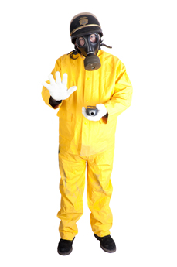 Scientists use the process of decay in radioactive isotopes called to determine the of organisms.
16. aging; carbon
17. radioactive aging; carbon
18. dating; age
19. carbon dating; age

1. State the general name for organisms that cause disease.
2. bacterium
3. antibody
4. pathogen
5. virus
6. Identify the chemicals or drugs that kill bacteria
7. Biotics
8. Antibiotics
9. Aspirin
10. Antifungicides

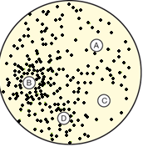

Four paper discs were soaked in antibiotics. The discs were placed on a plate with a large number of colonies of bacteria. The aim of the experiment was to test the effectiveness of the antibiotics. After three days the plate was examined. The results are shown above.

Identify the antibiotic that was most effective in killing the bacteria.

1. A
2. B
3. C
4. D
5. Which of these will be in the first line of defence?
6. Skin
7. Fever
8. T-cells and B cells
9. White blood cells
10. The products of the body’s endocrine system are
11. ions.
12. hormones.
13. enzymes.
14. minerals.
15. Which observation led to the hypothesis of seafloor spreading?

a. The claim of a large land mass referred to as Pangaea.

b. That there is a Global Rift system and undersea mountains.

c. Scientists in 1872 discovering a mountain ridge in the Atlantic Ocean.

d. The earth has several layers with different physical properties.

1. What is the most correct definition for a secondary wave?
2. Longitudinal wave that is the faster than a primary wave and can travel through solid, liquids and gases.
3. Longitudinal wave that is the slower than a primary wave and can travel through solid, liquids and gases
4. Transverse wave that is faster than a primary wave and can travel through solid, liquids and gases
5. Transverse wave that is slower than a primary wave and can travel through solid, liquids and gases
6. An island wave such as the Hawaiian Islands, provided evidence for which tectonic process?
7. Plate movement
8. Subduction
9. Collision boundaries
10. Rifting
11. When was the supercontinent, Pangea, formed on the surface of the Earth?
12. 50 - 75 million years ago
13. 5-10 million years ago
14. 100- 150 million years ago
15. 200- 250 million years ago
16. Which of the following is the correct order of the layers of the Earth, from the centre to the surface?
17. Crust, Mantle, Outer Core, Inner Core
18. Inner Core, Outer Core, Mantle, Crust
19. Outer Core, Inner Core, Mantle, Crust
20. Mantle, Inner Core, Crust, Outer Core

**Year 9 Science 9.01/9.05**

**Semester 2 Exam 2019**

**MULTIPLE CHOICE ANSWER BOOKLET**

**NAME:**

**FORM: DATE:**

|  |  |
| --- | --- |
| **I CAN STATEMENTS** | **QUESTIONS** |
| **MUST**  Explains global features and events in terms of geological processes and timescales.  Describes natural radioactivity as a substance giving out energy and particles in order to become more stable.  Analyses how biological systems function and respond to external changes, describing them in general terms. | 1, 2, 3, 8, 9, 10, 11, 14, 15, 17, 18, 19, 20, 21, 22, 24, 25, 26, 27, 28, 29, 30 |
| **SHOULD**  Explains in detail global features and events in terms of geological processes and timescales.  Explains natural radioactivity as atomic nuclei giving out energy and particles in order to become more stable. Describes the general properties of radioactive emissions.  Analyses how biological systems function and respond to external changes and compares the functions of different biological systems. | 5, 6, 7, 13, 146, 21, 22, 26, 27, 30 |
| **COULD**  Explains in detail how global features and events result from geological processes which change Earth’s surface over geological timescales.  Explains natural radioactivity as unstable atomic nuclei giving out alpha and beta particles or gamma radiation in order to become more stable. Describes the properties of alpha, beta and gamma radiation.  Analyses in detail how biological systems function and respond to external changes, and describes how different biological systems coordinate. | 4, 23, 29, 30 |

**SECTION ONE: Multiple choice answers Place a cross (X) through the correct answer.**

|  |  |  |  |  |  |  |  |  |  |  |
| --- | --- | --- | --- | --- | --- | --- | --- | --- | --- | --- |
| **1** | **a** | **b** | **c** | **d** |  | **11** | **a** | **b** | **c** | **d** |
| **2** | **a** | **b** | **c** | **d** |  | **12** | **a** | **b** | **c** | **d** |
| **3** | **a** | **b** | **c** | **d** |  | **13** | **a** | **b** | **c** | **d** |
| **4** | **a** | **b** | **c** | **d** |  | **14** | **a** | **b** | **c** | **d** |
| **5** | **a** | **b** | **c** | **d** |  | **15** | **a** | **b** | **c** | **d** |
| **6** | **a** | **b** | **c** | **d** |  | **16** | **a** | **b** | **c** | **d** |
| **7** | **a** | **b** | **c** | **d** |  | **17** | **a** | **b** | **c** | **d** |
| **8** | **a** | **b** | **c** | **d** |  | **18** | **a** | **b** | **c** | **d** |
| **9** | **a** | **b** | **c** | **d** |  | **19** | **a** | **b** | **c** | **d** |
| **10** | **a** | **b** | **c** | **d** |  | **20** | **a** | **b** | **c** | **d** |

**SECTION TWO - SHORT ANSWER SECTION**  **[42** marks]

This section has **6** questions. Answer **all** questions in the spaces provided. ____________________________________________________________________________

**Question 21**

1. For the electron configuration of the atom given below, construct an electron diagram and write the name of the element you have drawn. Use this atom to answer all parts of this question. (2 marks)

(**Electron diagram: 1 mark Name of the element: 1mark)**

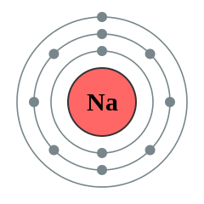

Electron Configuration: **2, 8, 1**

Element: **Sodium**

1. Identify (i) Number of electrons in the valence shell: 1 (1mark)

(ii) Type of ion formed: cation (1mark)

1. Draw the complete electron shell diagram for the ion that is formed by this atom. (3 marks)

1 mark if have electron shells correct with additional electron drawn in ie 2,8

1 mark for drawing in the square brackets

1 mark for identify charge outside of bracket as +1

1. State the electron configuration of the ion. ( 1 marks) 2,8
2. Demonstrate how the charge on the ion is calculated ie provide the sum. ( 2 marks)

P= 11=+11 (0.5)

E=10=-10 (0.5)

Total=-1 (0.5)

(0.5) set up like a sum showing all working out indicating numbers and charges

**Question 23**

Carbon has different isotopes, as shown in the diagram below.

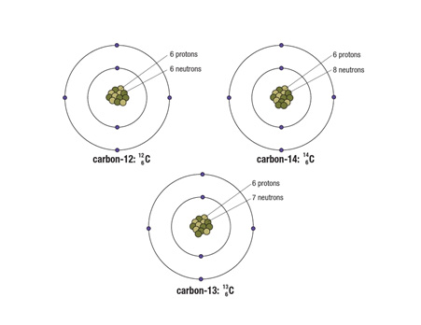

Describe the similarities and differences between these shown. (3 marks)

**Similarities Any 2 of the following (1 mark each)**

* **All of the atoms of carbon have the same atomic number = 6 = number of protons**
* **All isotopes have same number of electrons**
* **All of isotopes have same number of shells or orbits**

**Differences (1mark)**

* **Each of the atoms is a different isotope of carbon, which means that they have different numbers of neutrons in the nucleus**

**Question 24**

The atoms below are written using the letters V to Z instead of their correct chemical symbols.

     (4 mark)

1. Which two atoms have the same number of neutrons?

**Y and Z**

1. Which atom has the smallest mass number?

**W**

1. Which two atoms belong to the same element?

**X and Y**

1. Which atom has the electron configuration 2, 8?

**W**

**Question 25**

This paragraph has some missing words. Place the correct answers in the spaces below. (3 marks)

**charge electrons negatively nucleus protons Rutherford**

Ernest **Rutherford** proposed a new model for the atom where there is a small positively-charged **nucleus** surrounded by **negatively**-charged electrons. Later on scientists discovered that there were two types of particles inside the nucleus—positively-charged **protons** and neutrons, with no **charge** . The number of protons is always the same as the number of **electrons**.

**Question 26**

1. Explain the three lines of defence that the body has to prevent infection. (**3 marks**)

|  |  |  |
| --- | --- | --- |
| **Line of Defence** | **One Example** | **How does it prevent infection?** |
| 1st | ***Skin***  ***Mucous Membrane – ear, snot, urine, tears*** | ***Act as a barrier (1)***  ***OR***  ***Prevents bacteria/virus from entering the body (1)*** |
| 2nd | ***Fever***  ***Swelling/inflammation***  ***White blood cells*** | ***Any of the possible combinations receive (1)***  ***Signal, identify, begin to destroy, inflame the area*** |
| 3rd | **T cells**  **B cells**  **Memory cells** | ***Any of the possible combinations receive (1)***  ***Destroy, consume, attack to specifically attack using antibodies*** |

**Question 27**

Compare and contrast viruses and bacteria.

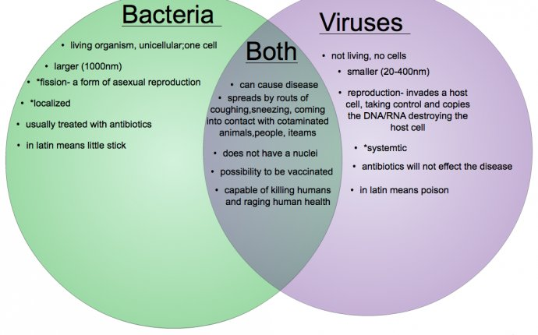

In the Venn diagram include the following information.

* 1. State two similarities. (2 marks)
  2. State two differences. (4 marks)
  3. Name at least one treatment you can use for a bacterial and viral infection. (2 marks)

**Question 28**

**Label 8 of the plates on the map below (4 marks)**

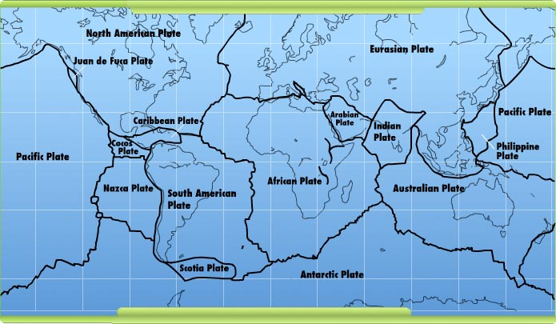

**Question 29**

**Fill in the table below about the types of boundaries. (6 marks)**

|  |  |  |  |
| --- | --- | --- | --- |
| Type of boundary | Draw a diagram to show how 2 plates would interact | Landscape that forms at this boundary | Does an earthquake/ volcano occur here? |
| **Converging (1/2)** | **(1/2)** | **Volcano, mountain, ocean trench (1/2)** | **no(1/2)** |
| **Diverging (1/2)** | **(1/2)** | **Ridge, valleys, underwater mountains (1/2)** | **Yes (1/2)** |
| **Transform (1/2)** | **(1/2)** | **Faults, fracture (1/2)** | **Yes (1/2)** |

**SECTION THREE: Extended Response (5 marks)**

1. Some isotopes of the elements are unstable. This means they may undergo decay or change into another isotope and emit certain radiations.
2. List three types of radiation in order from least penetrating to most penetrating.
3. Compare the (similarities and differences) properties of those radiations. You need to show at least two properties for each radiations.
4. What do you mean by the term half-life of a radioactive material?
5. **Alpha, Beta and Gamma radiation 1- mark ( wrong order give ½ mark if they wrote names correctly)**

**b ) Similarities ( Any 1 of the following 1 mark)**

* **These are all produced by nuclear activity.**
* **Unstable atoms eject these particles from their nucleus due to nuclear reactions.**
* **They can damage cells of living organisms.**

**Differences**

**Alpha (α) particles (Any two properties ½ mark each. Total: 1 mark)**

* **An alpha particle is identical to the nucleus of a helium nucleus. It contains two protons and two neutrons.**
* **Alpha particles are large, heavy and slow (10% of speed of light).**
* **They can only travel a few centimetres in air and is easily stopped by a thin sheet of paper or dead skin**

**Beta (β) particles (Any two properties ½ mark each. Total: 1mark)**

* **Beta particles are identical to electrons and therefore are very small and have a negative charge.**
* **The beta particles that make up beta radiation are small and fast (90% of speed of light). This means that beta radiation penetrates the skin more deeply than alpha radiation.**
* **Beta radiation can be blocked by a thin plate of aluminium.**

**Gamma (γ) radiation (Any two properties ½ mark each. Total: 1 mark)**

* **Gamma radiation can travel through skin, bone and aluminium, making it extremely dangerous to humans**
* **A thick layer of concrete or lead can block the radiation**
* **Gamma radiation is made up of electromagnetic waves rather than particles.**
* **Gamma rays do not have any mass or charge and travel at the speed of light.**

**C ) The half-life of a radioactive material is the time taken for half of the radioactive nuclei in a sample to decay. (1 mark)**

**END OF EXAM**

Please check your work!